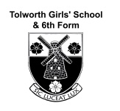 | YEAR 12 TRANSITION PROGRAMME – SUMMER WORK  Religious Studies – Philosophy, Ethics & Islam
Welcome to RS Philosophy and Ethics – you have chosen an excellent A-level Subject!
There is a big step up to A-level from GCSE and you will need to develop a very different style of learning in order to succeed. A-levels are advanced qualifications and so require much more of you as the student. Preparing you for independent learning is a central part of it.
Overview | In order to prepare for the start of Year 12 Philosophy & Ethics, and familiarise yourself with some of the content and skills needed for A-Level, we would like you to complete the following tasks before we start in September.
Activity | Independent Study Tasks:
Read the EDEXCEL Subject syllabus so you have a good idea about what the course involves and how your work is assessed.
https://qualifications.pearson.com/en/ qualifications/edexcel-a-levels/religious-studies-2016.html

Look for::
Philosophy 0f Religion,
Ethics and
Study of Religion: Islam

Time: 15 mins
Background Knowledge on Ethics | Listen to obtain a basic background knowledge of the workings of Ethics.  This will complement the work explored in your Ethics taster session and will help you with the first couple of weeks’ course, especially.  https://www.bbc.co.uk/programmes/p003hyc8  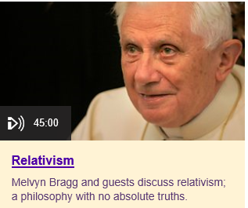  From this, you should be able to explain what relativism and absolutism is and be able to offer some strengths and weaknesses of both.  Time: 1hr (Ethics)
Watch the TED talk which looks at how plenty of good things are done in the name of religion, and plenty of bad things too. But what is religion, exactly — is it good or bad, in and of itself?

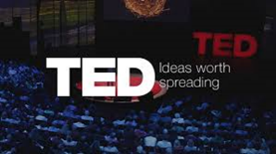
Is Religion Good or Bad?
TED Talks – Kwame Anthony Appiah
Time: 40m (Ethics and Religion)

Watch a virtual exhibition online.
Most galleries are posting tours of their permanent or temporary collections.
Visit a gallery you haven’t been to before.
https://www.metmuseum.org/about-the-met/curatorial-departments/islamic-art
https://www.p4panorama.com/Gallery.aspx/grand-mosque-abu-dhabi-360-virtual-tour/
If you download the Sites in VR app you can virtually visit a range of mosques, including Dome of the Rock, Umayyad Mosque in Damascus, the Prophet's mosque and Blue Mosques.

Tour three mosques and find out why they are historically significant.
Write some notes on your favourite mosque and why it appeals to you.

Time: 1.5hrs (Islam)
Listen to this podcast exploring the idea of original sin and its impact on politics, gender and notions of morality in western culture, examining Augustine, Milton, the Masaccio frescoes and Charles Darwin.
The Fall
BBC In Our Time podcast
Time: 45 mins (Philosophy)
Explain why you think that the following arguments work (valid) or do not work (invalid). Be as clear as you can.
A valid argument is one where if the opening premises are accepted (the first two in each argument) the conclusion (the thirdstatement) has to be accepted as well.)

1) Some bald men cycle to work
2)All those who cycle to work own or have borrowed a cycle.
3) Therefore, some bald men own a cycle.

1) All firemen are brave people
2) Some brave people are compassionate
3)Therefore, some firemen are compassionate.

1) No Martians have red noses
2) Rudolph has a red nose
3) Therefore, Rudolph is not a Martian

Time: 15 mins (Philosophy)
Watch How Islam began in under ten minutes? The turbulent tale is told against the clock, with all the names, dates and events on a timeline.

https://www.truetube.co.uk/film/how-islam-began-ten-minutes?tab=film

Use the following key words to create 6 separate ideas on the topic:
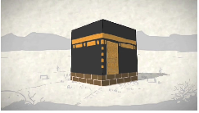
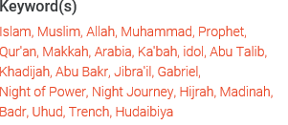

Time: 30 mins (Islam)
Watch one of the most controversial topics in Medical Ethics today, from the popular series, Middle Ground.
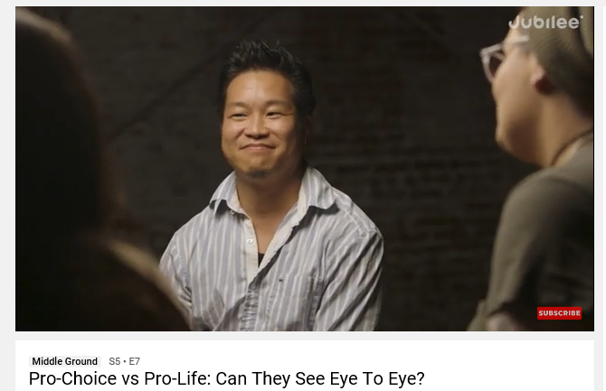

Explain the poverty discussion – how does poverty affect this important debate?

Do you agree that “men should not be a part of the conversation”?

Time: 30 mins (Ethics)
Find a news website you trust and will use to keep up to date with the news in Year 12; this will be a minimum expectation of the course.
The Andrew Marr Show – BBC, Sunday Morning – Senior politicians interviewed by Andrew Marr
Question Time – BBC, Thursday Evening – Political debate with a live studio audience
The News- BBC/ITV/Channel 4/Sky News – It is important to watch a range of channels.
BBC News – Ethics

Summer Reading
Take this list to your local library and they will be able to get the books for you.
Philosophy: Themes - Julian Baggini
Being Good: A Short Introduction to Ethics - Simon Blackburn
The Puzzle of Ethics - Peter Vardy
The Thinkers Guide to Evil - Peter Vardy
No God but God - Reza Aslan
Islam: a Short History - Karen Armstrong
A Student's Approach to World Religion: Islam- Victor Watton
Films to get you thinking about themes in Philosophy & Ethics
Film | Philosophical/Ethical Themes | Questions to think about
Alive | Ethics and morality | How far would you go to survive?
The Truman Show | Reality, Free will and determinism | How do you know the world around you is real?
Minority Report | Free Will and Determinism | Do we choose our choices?
The Matrix | Dualism, Consciousness, Existence, Free Will | What is real? What do we know?
Being John Malkovich | Personal Identity | What makes me, me?
Little Buddha | Reincarnation, Life of the Buddha | What happens after I die?
Dogma | Christian Doctrine and Religious Experience | Is religion fact?
The Adjustment Bureau | Free Will and existence of immaterial beings | What causes events to happen?
Constantine | Demonology, Life after Death | Is there an ‘immaterial’?
Bruce Almighty | Religious Experience | What is God like?
Inception | Skepticism, | What is reality?
Pi | Rational Knowledge | How can we have knowledge?
Inherit the Wind | Atheism | What dictates our beliefs?

Please complete the set tasks by September.

