Progression to Post-16 Study in Information Technology

Course Outline
The business course has four units. They are:
- Information Technology Systems – an externally assessed unit where you will learn about the theory relating to information technology use, such as hardware, software, networks, as well as considering the ethical and legal issues surrounding IT use

- Creating Systems to manage information – an externally assessed unit that requires you to complete a practical task to create a database for a specific purpose

- Using social media in business – this unit requires you to complete an internally assessed coursework unit where you will analyse and evaluate different social media platforms and how they can be used by businesses. You will also need to plan, create, test and evaluate a social media site for a local business of your choice

- Data Modelling – in this unit you will learn how to use spreadsheet programs. For the internal assessment you will need to plan, create, test and evaluate a spreadsheet model for a specific purpose

Throughout the course you will need to use and improve upon a range of IT skills, including
- Internet research – being discerning and selective

- Word processing – the coursework will need to be presented, often as a business report

- Presentation using PowerPoint – some coursework tasks, require a presentation

- Email – using this in a professional manner to liaise with staff and clients

- Spreadsheets – to analyse and present numerical data, for example a bar chart

- Referencing sources – this must be done using the Harvard referencing system. Information on how to do this can be found here https://www.ukessays.com/referencing/harvard/

Recommended Resources
https://www.bbc.co.uk/bitesize/levels/z98jmp3 - Whilst aimed at GCSE, this will also provide useful information on many areas, especially if you did not do GCSE Computing. You can use the information in the ICT, Computing and Digital Technology areas
https://www.bbc.co.uk/news/technology - this area of the BBC news website will provide you with up-to-date information on technology development
www.teach-ict.com – a website totally devoted to IT and Computing. The username is and the password is
https://www.knowitallninja.com/ - a website dedicated to L3 BTEC. Especially useful for Unit 1
https://www.thinkuknow.co.uk/ - website for e-safety advice
Pearson Textbook – provided by the school
PG Online textbook – excellent for Unit 1 theory
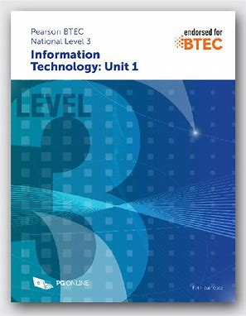
Pearson Revision Guide – invaluable for the externally assessed units
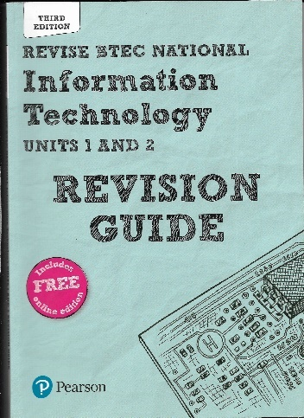
Preparatory Activities
Week | Date | Activities
1 | 4 - 8 May | Digital divide  The digital divide is one ethical, social and moral issue surrounding the use of IT.  Complete the following using the recommended resources:  - Define the term digital divide  - Explain causes of the digital divide  - Find evidence to prove that the digital divide exists, i.e. the % of people with internet connection across countries  - What are the impacts of the digital divide for individuals, businesses and society as a whole?  - What can businesses or other organisations do in order to minimise the digital divide and its consequences?  You can present this as either a PowerPoint presentation or a word document. Include a bibliography of the sources that you have used.
2 | 11-15 May | History of computing  Charles Babbage is considered to be the father of the concept of the programmable computer, as long ago as 1820. However, it has taken many years for computers to be as commonplace as they are today.  Investigate Charles Babbage and other important figures in the history of commuting:  - Ada Lovelace  - Alan Turing  - Tim Berners-Lee  - Alan Sugar  Present your work as a word-processed document to include background information on each person, an image, what they did that is so significant in the history of computing. Remember to include a bibliography
3 | 18-22 May | Social Media  Facebook is now the most widely used social media platform, but it was not the first, nor was it invented for the purpose that it is used for today.  Produce a word processed report about social media use that includes:  - The names of a range of social media platforms with information about when, where, why they were launched  - Data and analysis about the use of social media – which are the most used platforms, is this different across different countries, continents, or age groups  - Benefits and limitations of social media use for (a) individuals and (b) business organisations  - At least one example of where an individual has had their career impacted due to improper social media use  - A bibliography
4 | 25-29 May | Connectivity  Read this article from the bbc: https://www.bbc.co.uk/news/technology-52414280  - What is an ethernet cable?  - What is bandwidth?  - Why does more people using the internet affect the speed?  - Why would gaming need a faster speed than general browsing?  - Use this resource: https://www.knowitallninja.com/modules/connectivity/ to complete the tasks on wired and wireless connectivity  Present your answers as two word-processed files
5 | 1-5 June | Computer Systems  This task is all about understanding what is meant by a computer system.  The following sources will be useful:  LINK 1  LINK 2  VIDEOS  - Make a collage or mind map of examples of computer systems  - Explain what is meant by the input-process-output cycle  - Explain the use, advantages and disadvantages of at least FOUR input devices  - Explain the use, advantages and disadvantages of at least FOUR output devices  - Explain the use, advantages and disadvantages of at least FOUR storage devices  - Cloud storage is a method where storage is not on a physical device, but on a remote server. Analyse the pros and cons of using cloud storage on (a) an individual and (b) on organisations  - A bibliography  Present the work as a word-processed report
6 | 8-12 June | Emerging technology  Emerging technology is new technology. Select FOUR from the following:  - Artificial intelligence  - Biometrics  - Robotics  - Virtual reality  - Drones  - Augmented reality  - 3D printing  - Internet of things  For each one you select do the following  - Explain what this technology is  - Explain how it could be used by individuals at home  - Explain how it could be used within the workplace  - Implications of these emerging technologies -both positive and negative  Present the tasks as a word-processed document
7 | 15-19 June | Spreadsheet Key terms  - Use the suggested resources to define the following terms which are used in spreadsheets. Include screenshots if you can to help your definitions  - Workbook  - Worksheet  - Column  - Row  - Cell  - Active cell  - Formula  - Function  - Cell reference  - Absolute cell reference  - Conditional formatting  - Explain who might use spreadsheets and what for  - Analyse the benefits and limitations of using spreadsheets rather than paper and a calculator  - Explain how a spreadsheet program can be used to format the data within a spreadsheet to improve the look and make it easier to use  Present this as one word-processed document.
8 | 22-26 June | Spreadsheet practical task 1  You will need to use excel for this task (available through your Office 365 login)  Download the file provided and the instruction sheet  Work through the tasks and submit your finished spreadsheet
9 | 29 June-3 July | Spreadsheet practical task 2  You will need to use excel again for this task (available through your Office 365 login)  Download the file provided and the instruction sheet  Work through the tasks and submit your finished spreadsheet
10 | 6 – 10 July | Database key terms  - Use the suggested resources to define the following terms which are used in databases  - Database  - Table  - Field  - Record  - Data type  - Validation  - Verification  - Flat file database  - Relational database  - Primary key  - Query  - Form  - Explain who might use a database and what for  - Analyse the benefits and limitations of using a database rather than paper records  Present this as a word-processed document with images if you think this will help.
11 | 13-17 July | E-safety / PowerPoint practical task  Imagine you have been asked to lead an assembly for the new Year 7s on e-safety. Create a PowerPoint for this purpose. You will need to include:  - A suitable title page  - Several clearly laid out slides that include images as well as text  - Speakers notes for each slide that go into more detail about what would be said  - An embedded video  - A final slide with links to place for extra help / information  A bibliography in the speaker’s notes are of the final slide.
12 | 20-24 July | Legal issues  The Computer Misuse Act is one of the laws that relate to ICT use.  Research the following and present in a word-processed document:  - The main role of the law, i.e. what does it say is illegal  - The impact on organisations of the law  - The impact on individuals of the law  - The consequences of not following the law on (a) an individual and (b) a business  - A news story where an organisation has failed to comply with this law, and the outcome of the incident  Present this as a word-processed document.

