GCSE to AS French

Cahier d’exercices

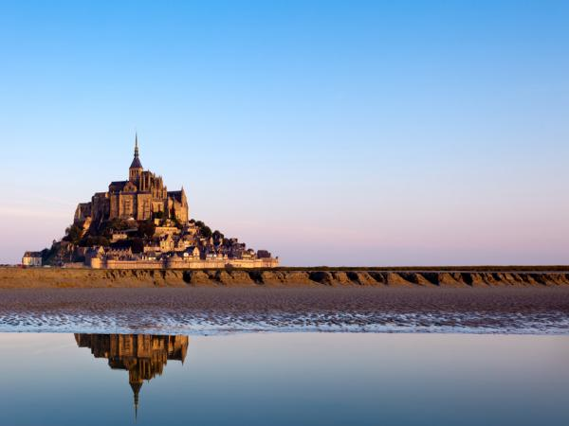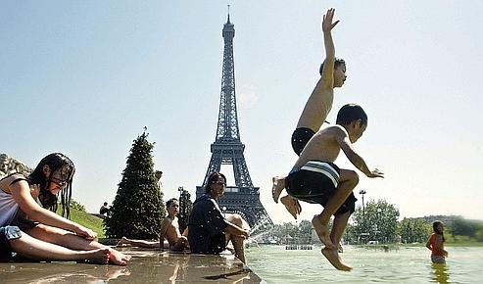

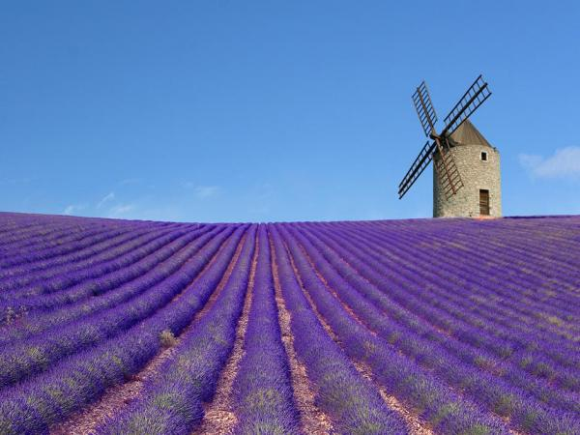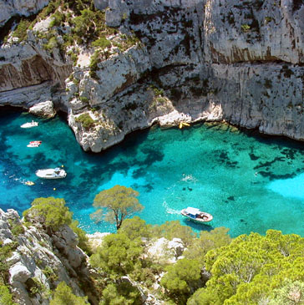

**Les nombres**

**C:\Documents and Settings\sylvain.warton\Local Settings\Temporary Internet Files\Content.IE5\BC5XZ7OT\MC900295558[1].wmf**

**Calcule le résultats des opérations, écris en lettres:**

Ex: 12 + 18 = ***trente***

*25 + 25 =*

*30 + 32 =*

*7 x 10 =*

*89 – 3 =*

*112 – 20 =*

*10 x 14 =*

*543 + 467 =*

**Calcule le résultats des opérations, écris en chiffre:**

Exemple: Douze **+** vingt = ***32***

Quinze **+** quatre-vingt-cinq =

Soixante-dix **+** trente-huit =

Quatre-vingt-dix-huit **+** deux =

Deux mille six **+** cinquante-neuf =

**Complète les séquences logiques :**

zéro, cinq, dix, ……………..………………, ……………..………………,

dix, ……………..………………, trente, quarante, ……………..………………,

Soixante-neuf, ……………..………………, soixante-treize, soixante-quinze.

…………………………………., quatre-vingt-seize, quatre-vingt-dix-huit, cent.

**Vocabulaire: La nourriture et les boissons**

1. **C:\Documents and Settings\sylvain.warton\Local Settings\Temporary Internet Files\Content.IE5\BXI13SJ7\MC900078763[1].wmfCherche le vocabulaire et découvre le message caché:**

|  |  |  |  |  |  |  |  |  |  |  |  |  |  |  |
| --- | --- | --- | --- | --- | --- | --- | --- | --- | --- | --- | --- | --- | --- | --- |
| **T** | **B** | **A** | **E** | **G** | **U** | **E** | **S** | **T** | **T** | **E** | **P** | **E** | **P** | **L** |
| **S** | **A** | **Y** | **H** | **Z** | **T** | **G** | **E** | **A** | **X** | **M** | **T** | **I** | **P** | **E** |
| **C** | **T** | **L** | **T** | **O** | **E** | **Q** | **J** | **N** | **N** | **R** | **X** | **E** | **T** | **G** |
| **E** | **S** | **I** | **O** | **A** | **V** | **J** | **H** | **Y** | **A** | **D** | **Z** | **G** | **I** | **U** |
| **E** | **G** | **C** | **U** | **C** | **O** | **I** | **I** | **T** | **Y** | **N** | **W** | **V** | **A** | **M** |
| **C** | **T** | **A** | **O** | **R** | **O** | **A** | **A** | **J** | **U** | **S** | **A** | **I** | **L** | **E** |
| **A** | **R** | **N** | **M** | **W** | **F** | **H** | **E** | **N** | **Q** | **M** | **J** | **B** | **C** | **S** |
| **L** | **N** | **S** | **G** | **O** | **M** | **B** | **C** | **D** | **D** | **V** | **J** | **U** | **U** | **H** |
| **G** | **M** | **I** | **S** | **L** | **R** | **M** | **T** | **B** | **A** | **E** | **P** | **A** | **I** | **N** |
| **I** | **T** | **R** | **S** | **N** | **O** | **F** | **H** | **G** | **A** | **L** | **E** | **J** | **F** | **E** |
| **U** | **X** | **N** | **S** | **I** | **V** | **O** | **P** | **M** | **P** | **T** | **A** | **G** | **R** | **M** |
| **E** | **R** | **I** | **O** | **P** | **A** | **C** | **T** | **F** | **A** | **V** | **R** | **S** | **C** | **M** |
| **J** | **A** | **M** | **B** | **O** | **N** | **R** | **Z** | **G** | **I** | **Y** | **X** | **W** | **Y** | **O** |
| **J** | **D** | **Z** | **I** | **N** | **G** | **D** | **T** | **Z** | **Y** | **F** | **H** | **C** | **J** | **P** |
| **V** | **B** | **I** | **N** | **B** | **N** | **Q** | **T** | **R** | **U** | **O** | **A** | **Y** | **W** | **P** |

|  |  |  |
| --- | --- | --- |
| BANANE | CHOCOLAT | EAU |
| FROMAGE | FRUITS | GATEAU |
| GLACE | JAMBON | JUS |
| LAIT | LEGUMES | PAIN |
| POIRE | POMME | RAISIN |
| SALADE | SANDWICH | TARTE |
| THE | VIANDE | YAOURT |

**MOT CACHE: __ __ __ __ __ __ __ __**

1. **Traduis le vocabulaire en anglais, ex: une banana *= a banana***
2. **Cherche le genre des mots (masculin ou féminin) et écris *le, la, l’, les*, ex: *la* banane**

**C:\Documents and Settings\sylvain.warton\Local Settings\Temporary Internet Files\Content.IE5\BC5XZ7OT\MC900241595[1].wmfCRYPTOGRAMME : Pour être en bonne santé…**

1. **Cherche le message codé**, **le texte commence avec la phrase:** “*Pour être en bonne santé*...”

2. **Traduis** le texte en français

3. Following the model, **write a small paragraph** of your own to say what you have to do to be healthy. *Use past and future tenses to reach level 6.*

|  |  |  |  |  |  |  |  |  |  |  |  |  |  |  |  |  |  |  |  |  |  |  |  |  |  |
| --- | --- | --- | --- | --- | --- | --- | --- | --- | --- | --- | --- | --- | --- | --- | --- | --- | --- | --- | --- | --- | --- | --- | --- | --- | --- |
| A | B | C | D | E | F | G | H | I | J | K | L | M | N | O | P | Q | R | S | T | U | V | W | X | Y | Z |
|  |  |  |  |  |  |  |  |  |  |  | **26** | **7** | **6** |  |  |  | **19** |  |  |  |  |  |  |  |  |

|  |  |  |  |  |  |  |  |  |  |  |  |  |  |  |  |  |  |  |  |  |  |  |  |
| --- | --- | --- | --- | --- | --- | --- | --- | --- | --- | --- | --- | --- | --- | --- | --- | --- | --- | --- | --- | --- | --- | --- | --- |
| __ | __ | __ | R |  | Ê | __ | R | __ |  | __ | N |  | __ | __ | N | N | __ |  | __ | __ | N | __ | É |
| **18** | **15** | **11** | **19** |  |  | **3** | **19** | **14** |  | **14** | **6** |  | **17** | **15** | **6** | **6** | **14** |  | **10** | **5** | **6** | **3** |  |

|  |  |  |  |  |  |  |  |  |  |  |  |  |  |  |  |  |  |  |  |  |  |
| --- | --- | --- | --- | --- | --- | --- | --- | --- | --- | --- | --- | --- | --- | --- | --- | --- | --- | --- | --- | --- | --- |
| __ | L |  | __ | __ | __ | __ |  | __ | __ | __ | R | __ |  | __ | __ | __ | __ | __ | __ | __ | __ |
| **24** | **26** |  | **4** | **5** | **11** | **3** |  | **17** | **15** | **24** | **19** | **14** |  | **17** | **14** | **5** | **11** | **9** | **15** | **11** | **18** |

|  |  |  |  |  |  |  |  |  |  |  |  |  |  |  |  |  |  |  |  |  |  |  |  |  |  |
| --- | --- | --- | --- | --- | --- | --- | --- | --- | --- | --- | --- | --- | --- | --- | --- | --- | --- | --- | --- | --- | --- | --- | --- | --- | --- |
| __ | ' | __ | __ | __ | , |  | __ | __ |  | __ | __ | __ | __ | __ | __ | R |  | __ | __ |  | __ | __ | N | N | __ |
| **20** |  | **14** | **5** | **11** |  |  | **10** | **14** |  | **9** | **15** | **11** | **9** | **21** | **14** | **19** |  | **20** | **14** |  | **17** | **15** | **6** | **6** | **14** |

|  |  |  |  |  |  |  |  |  |  |  |  |  |  |  |  |  |  |  |  |  |  |  |  |
| --- | --- | --- | --- | --- | --- | --- | --- | --- | --- | --- | --- | --- | --- | --- | --- | --- | --- | --- | --- | --- | --- | --- | --- |
| __ | __ | __ | R | __ |  | __ | __ |  | __ | __ | __ | R | __ |  | __ | __ |  | __ | __ | __ | R | __ | . |
| **21** | **14** | **11** | **19** | **14** |  | **14** | **3** |  | **4** | **5** | **24** | **19** | **14** |  | **20** | **11** |  | **10** | **18** | **15** | **19** | **3** |  |

|  |  |  |  |  |  |  |  |  |  |  |  |  |  |  |  |  |  |  |  |  |  |  |
| --- | --- | --- | --- | --- | --- | --- | --- | --- | --- | --- | --- | --- | --- | --- | --- | --- | --- | --- | --- | --- | --- | --- |
| __ | __ |  | __ | L | __ | __ | , |  | __ | L |  | __ | __ | __ | __ |  | M | __ | N | __ | __ | R |
| **20** | **14** |  | **18** | **26** | **11** | **10** |  |  | **24** | **26** |  | **4** | **5** | **11** | **3** |  | **7** | **5** | **6** | **23** | **14** | **19** |

|  |  |  |  |  |  |  |  |  |  |  |  |  |  |  |  |  |  |  |  |  |  |  |  |
| --- | --- | --- | --- | --- | --- | --- | --- | --- | --- | --- | --- | --- | --- | --- | --- | --- | --- | --- | --- | --- | --- | --- | --- |
| __ | __ | __ |  | __ | R | __ | __ | __ | __ |  | __ | __ |  | L | É | __ | __ | M | __ | __ |  | __ | __ |
| **20** | **14** | **10** |  | **4** | **19** | **11** | **24** | **3** | **10** |  | **14** | **3** |  | **26** |  | **23** | **11** | **7** | **14** | **10** |  | **14** | **3** |

|  |  |  |  |  |  |  |  |  |  |  |  |  |  |  |  |  |  |  |
| --- | --- | --- | --- | --- | --- | --- | --- | --- | --- | --- | --- | --- | --- | --- | --- | --- | --- | --- |
| N | __ |  | __ | __ | __ |  | __ | __ | M | __ | R | . |  | __ | __ | __ | N | __ |
| **6** | **14** |  | **18** | **5** | **10** |  | **4** | **11** | **7** | **14** | **19** |  |  | **13** | **11** | **5** | **6** | **20** |

|  |  |  |  |  |  |  |  |  |  |  |  |  |  |  |  |  |  |  |  |  |  |
| --- | --- | --- | --- | --- | --- | --- | --- | --- | --- | --- | --- | --- | --- | --- | --- | --- | --- | --- | --- | --- | --- |
| __ | ' | É | __ | __ | __ | __ |  | __ | L | __ | __ |  | __ | __ | __ | N | __ | , |  | __ | __ |
| **1** |  |  | **3** | **5** | **24** | **10** |  | **18** | **26** | **11** | **10** |  | **1** | **14** | **11** | **6** | **14** |  |  | **1** | **14** |

|  |  |  |  |  |  |  |  |  |  |  |  |  |  |  |  |  |  |  |  |  |  |  |  |  |
| --- | --- | --- | --- | --- | --- | --- | --- | --- | --- | --- | --- | --- | --- | --- | --- | --- | --- | --- | --- | --- | --- | --- | --- | --- |
| M | __ | N | __ | __ | __ | __ | __ |  | __ | __ | __ | __ | __ | __ | __ | __ |  | __ | __ |  | __ | __ | __ | __ |
| **7** | **5** | **6** | **23** | **14** | **5** | **24** | **10** |  | **17** | **14** | **5** | **11** | **9** | **15** | **11** | **18** |  | **20** | **14** |  | **4** | **5** | **10** | **3** |

|  |  |  |  |  |  |  |  |  |  |  |  |  |  |  |  |  |  |  |  |  |  |  |
| --- | --- | --- | --- | --- | --- | --- | --- | --- | --- | --- | --- | --- | --- | --- | --- | --- | --- | --- | --- | --- | --- | --- |
| __ | __ | __ | __ | . |  | __ | __ | N | __ |  | L | __ |  | __ | __ | __ | __ | R | , |  | __ | __ |
| **4** | **15** | **15** | **20** |  |  | **20** | **5** | **6** | **10** |  | **26** | **14** |  | **4** | **11** | **3** | **11** | **19** |  |  | **1** | **14** |

|  |  |  |  |  |  |  |  |  |  |  |  |  |  |  |  |  |  |  |  |  |  |  |  |
| --- | --- | --- | --- | --- | --- | --- | --- | --- | --- | --- | --- | --- | --- | --- | --- | --- | --- | --- | --- | --- | --- | --- | --- |
| __ | __ | __ | __ | R | __ | __ | __ |  | M | __ | __ | N | __ |  | __ | __ | __ | __ | __ | R |  | __ | __ |
| **16** | **15** | **11** | **20** | **19** | **5** | **24** | **10** |  | **7** | **15** | **24** | **6** | **10** |  | **18** | **5** | **10** | **10** | **14** | **19** |  | **20** | **14** |

|  |  |  |  |  |  |  |  |  |  |  |  |  |  |  |  |
| --- | --- | --- | --- | --- | --- | --- | --- | --- | --- | --- | --- | --- | --- | --- | --- |
| __ | __ | M | __ | __ |  | __ | __ |  | __ | __ | L | __ | __ | L | . |
| **3** | **14** | **7** | **18** | **10** |  | **5** | **11** |  | **10** | **15** | **26** | **14** | **24** | **26** |  |

**Exercice 3:**

**Vocabulaire: les médias**

**Complétez les mots croisés en français :**

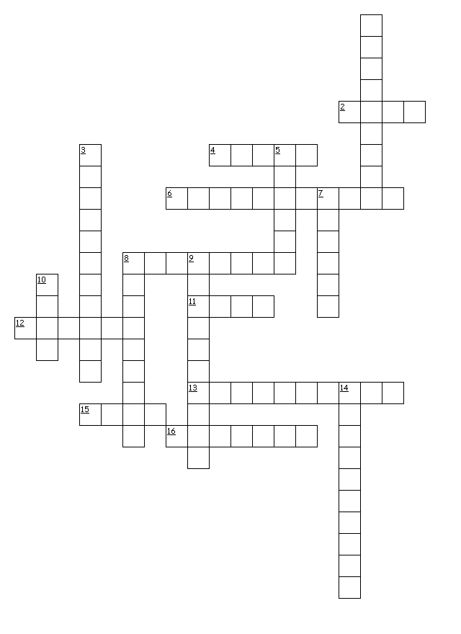

**Horizontal**

2. ipad

4. media

6. download

8. portable

11. link

12. social

13. smartphone

15. website

16. newspaper

**Vertical**

1. telephone

3. app

5. iphone

7. network

8. advertising

9. TV

10. blog

14. computer

**Un peu de grammaire!...**

**Write a definition of the following grammatical terms and give an example for each. You can use a dictionary or write them in your own words.**

**A noun:**

**A verb:**

**An infinitive verb:**

**A conjugated verb:**

**An adjective:**

**Adjectival agreement:**

**An adverb:**

**Read the text below and highlight the nouns, underline the adjectives, circle the verbs.**

On Saturday we went into a busy town. We saw lots of people who were all rushing to the shops. It was absolute chaos! In the shops there were clothes all on the floor and there was a lot of noise. The heat was unbearable because the air conditioning system was broken. Unfortunately there were not enough sales assistants to help us so we had to wait in a long queue. This was a nightmare. Next week we are going to the Trafford Centre instead. Hopefully it will be more organised and we can shop in peace. We’ll probably also grab a coffee and then go to a restaurant for lunch.

**Read the text below and highlight the nouns, underline the adjectives, circle the verbs.**

La télévision est un média formidable. On peut regarder des programmes de télévision extraordinaire et apprendre beaucoup de nouvelles informations. Personnellement, j’adore regarder les séries TV américaines car elles ont beaucoup d’action et les personnages sont généralement intéressants. Cependant, je déteste regarder des films britanniques parce que la réalisation est souvent nulle.

**Décris ces célébrités – utilise des adjectifs différents (attention au changement masculin/féminin)**

*Shawn Mendes est...*

* ***Riche***



[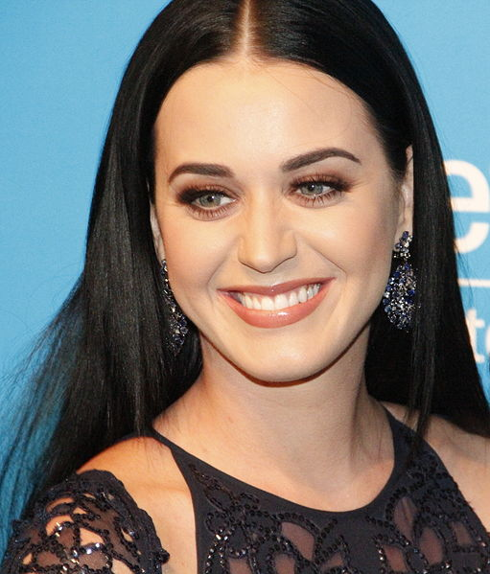](http://upload.wikimedia.org/wikipedia/commons/c/c2/Katy_Perry_UNICEF_2012.jpg)

*Katy Perry est...*

* ***Élégante***

**Formules d’expression, associez le francais et l’anglais:**

|  |  |  |
| --- | --- | --- |
| 1. Je pense que... *5* |  | 1. According to me |
| 1. Je crois que... |  | 1. As far as I’m concerned |
| 1. Je suis convaincu(e) que... |  | 1. I believe that |
| 1. Je suis persuadé(e) que... |  | 1. Personally |
| 1. J’estime que... |  | 1. I think that |
| 1. En ce qui me concerne... |  | 1. I estimate that |
| 1. Personnellement... |  | 1. I am convinced that |
| 1. Selon moi |  | 1. I am persuaded that |

**Le présent**

|  |  |  |
| --- | --- | --- |
| **-ER VERBS** KNOCK OFF ‘ER’ | **-RE VERBS**  KNOCK OFF ‘RE’ | **-IR VERBS**  KNOCK OFF ‘IR’ |
| **JouER →JOU…** | **répondRE →RÉPOND...** | **Finir →FIN…** |
| je jou***e*** (I) tu jou***es*** (you) il/elle/on jou***e*** (he/she/we/one) nous jou***ons*** (we) vous jou***ez*** (you) ils/elles jou***ent*** (they) | je répond***s*** (I) tu répond***s*** (you) il/elle/on répond (he/she/we/one) nous répond***ons*** (we) vous répond***ez*** (you) ils/elles répond***ent*** (they) | je fin***is*** (I) tu fin***is*** (you) il/elle/on fin***it*** (he/she/we/one) nous fin***issons*** (we) vous fin***issez*** (you) ils/elles fin***issent*** (they) |

C:\Documents and Settings\sylvain.warton\Local Settings\Temporary Internet Files\Content.IE5\BC5XZ7OT\MC900384400[1].wmfRegular verbs form the present tense in one of three ways, depending on whether the infinitive of the verb ends in –er, -re or –ir. We then remove these endings and add different ones depending on which person we are talking about.

**Complète les espaces par des lettres et traduis en anglais**

***PARLER= TO SPEAK***

Je parl**e** = ***I speak***

Tu parl_ _ =

Il/elle/on parl_ =

Nous parl_ _ _ =

Vous parl_ _ =

Ils/Elles parl_ _ _ =

**Conjugue les verbes entre parenthèses :**

1. Je *parle* avec ma sœur (parl**er**)
2. Il _________ la voiture (laver)
3. Ils ___________ de la musique (écouter)
4. Elle _________ avec son copain (danser)
5. Tu _________ à ta mère (téléphoner)
6. Vous _________ à la question (répondre)
7. On _________ des glaces ici (vendre)
8. Elles _________ leurs devoirs (finir)
9. Je __________ la bonne direction (choisir)
10. Il _____ dans le jardin (vomir)

**C:\Documents and Settings\sylvain.warton\Local Settings\Temporary Internet Files\Content.IE5\BC5XZ7OT\MC900297429[1].wmfLe futur proche**

Le futur proche (the near future) se forme avec le verbe « ALLER » (to go) conjugué, suivi d’un verbe à l’infinitif. C’est l’équivalent de « to be going to » en anglais.

Traduis en anglais :

|  |
| --- |
| **ALLER** |
| je vais |
| tu vas |
| il/elle/on va |
| nous allons |
| vous allez |
| ils/elles vont |

1. **je vais** jouer au football ***= I’m going to play football***
2. **tu vas** faire du ski =
3. **il va** aller au restaurant =
4. **elle va** cuisiner =
5. **on va** apprendre le français =
6. **nous allons** nous promener =
7. **vous allez** boire un verre =
8. **ils vont** étudier =
9. **elles vont** travailler =

|  |
| --- |
| **Vocabulaire:** |
| **this afternoon:** cette après-midi |
| **tonight**: ce soir |
| **this morning**: ce matin |
| **this summer**: cet été |

**Traduis en francais:**

1. I am going to watch a film this afternoon.
2. You are going to be tired tonight.
3. He is going to swim this morning.
4. She is going to go out with her friends.
5. We are going to eat at a French restaurant.
6. They are going to travel to Italy this summer.

**C:\Documents and Settings\sylvain.warton\Local Settings\Temporary Internet Files\Content.IE5\BC5XZ7OT\MC900295069[1].wmfChoisis la bonne réponse.**

1. C’est **mon / ma / mes** famille.
2. C’est **ta / ton / tes** téléphone ?
3. Quelle est **ton / votre / vos** adresse, s’il vous plaît ?
4. Il s’appelle Claude et **son / sa / ses** enfants s’appellent Julien et Richard.
5. J’adore **mon / ma / ta** amie.

⏭<http://www.bbc.co.uk/schools/gcsebitesize/french/grammar/possessivead/possesiveadjectiverev1.shtml>

**Complète avec le pronom personnel : *je, tu, il, elle, on, nous, vous, ils, elles***

1. ***Tu*** as 20 ans ?

2. ___ vais au cinéma ce soir.

3. ___ habitons à Marseille.

4. ___ aimez cuisiner ?

5. ___ ai 38 ans.

6. __ étudient à l’université.

7. __ avez un stylo ?

8. __ sommes anglais.

9. __ ont une belle voiture.

10. ___ êtes Monsieur Durand ?

**Complète avec la forme correcte des verbes être, avoir, habiter, s’appeler.**

Elle __________ Aurélie et elle __________ française. Elle __________ 28 ans. Elle __________ mariée avec un journaliste anglais. Ils __________ à Bordeaux. Ils __________ deux enfants : ils __________ Marie et Pierre. Marie __________ 4 ans et Pierre __________ 2 ans. Marie et Pierre __________ les yeux marron et les cheveux bruns. Marie __________ plus grande que Pierre.

**C:\Documents and Settings\sylvain.warton\Local Settings\Temporary Internet Files\Content.IE5\061ZMAP4\MC900440428[1].wmfComplète avec tes détails personnels :**

Nom :

Prénom :

Âge :

Adresse :

Ville :

Pays :

Téléphone :

E-mail :

**Ecris un texte de présentation :** nom, prénom, âge, description physique, personnalité, ville, famille, hobbies, ce que tu aimes ou détestes, ce que tu vas faire ce week-end, ce que tu as fait le week-end dernier, etc**.**

*Je m’appelle…*

**The World is Out There…**

1. **See a foreign language film at the cinema or watch one on Netflix. You can also access (for free) the French-German TV channel Arte. You can watch the programmes French or English subtitles**



1. **When lockdown is lifted, visit the Institut Français (nearest tube South Kensington) to use the library or watch a film (**[https://www.institut-francais.org.uk/)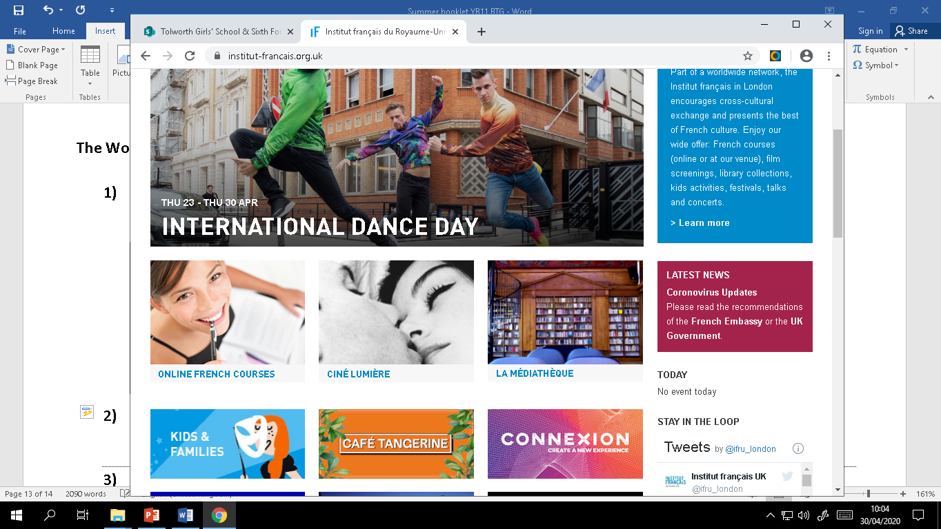](https://www.institut-francais.org.uk/))
2. **Have a Zoom meeting with any family you have in a Francophone country – impress them with how well your French has come on !**

C:\Documents and Settings\sylvain.warton\Local Settings\Temporary Internet Files\Content.IE5\SS1W7QSA\MC900078772[1].wmf